OUTPUT:
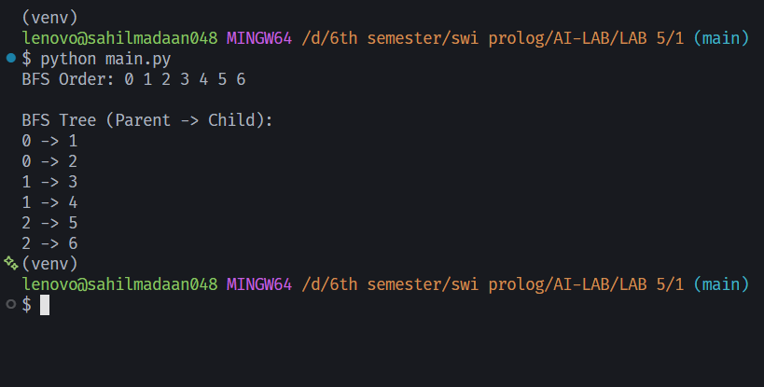

Lab 5
- BFS Traversal & Tree on a Given Graph
Perform BFS on the given graph starting from Node 0. Print the order in which nodes are visited. Also show the BFS tree by printing each node and its parent.
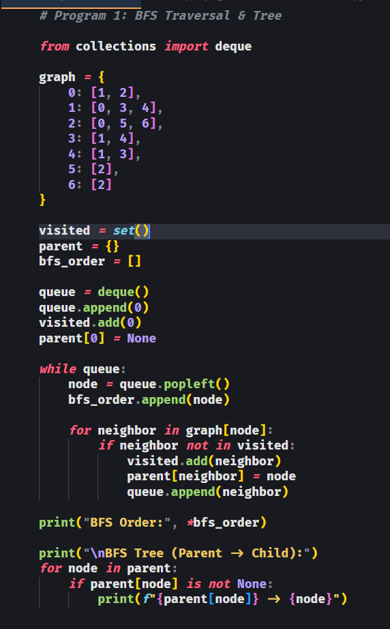

OUTPUT:
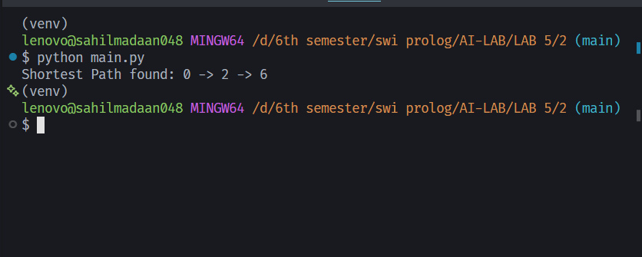

Lab 5
- Find a Path Between Two Nodes
Using BFS on the given graph, find if a path exists from Node 0 to Node 6. Print the complete path if found (e.g. 0 → 2 → 6), or print 'No path found'.
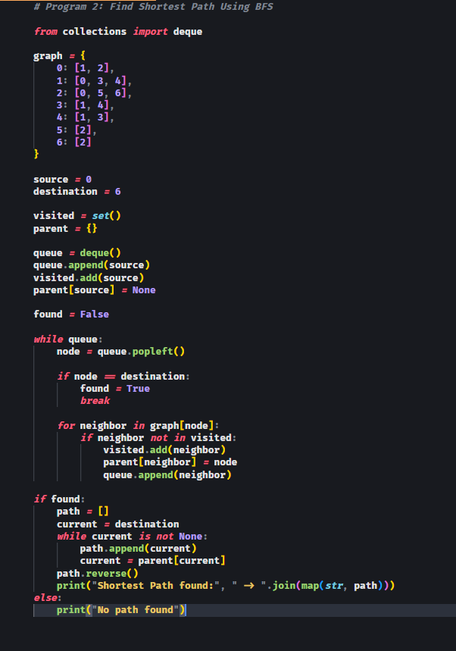

OUTPUT:

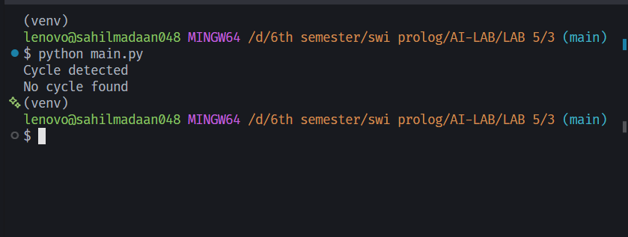

Lab 5
- Detect a Cycle in the Graph
Check whether the given graph contains a cycle using BFS. Print 'Cycle detected' or 'No cycle found'. Also test your program on a second graph
(a simple tree) to verify the 'No cycle' case
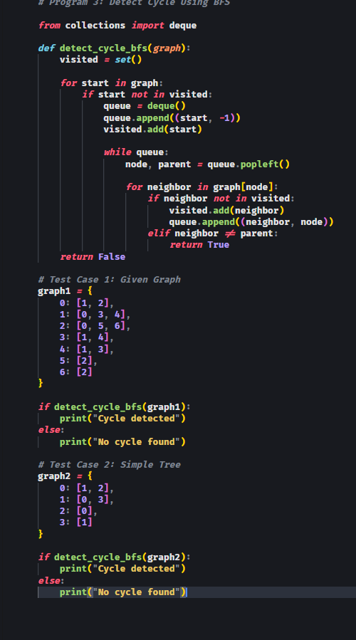

OUTPUT:

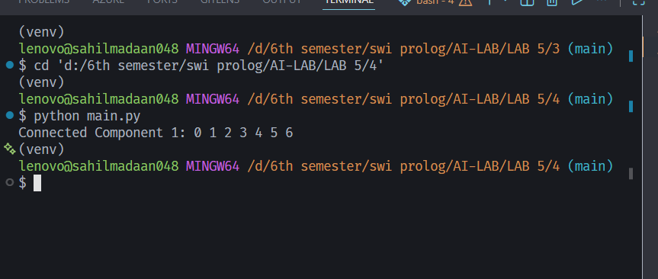

Lab 5
- Connected Components in the Graph
Find all connected components in the graph using BFS. Print the nodes in each component separately.
